**Forecasting Dog-Mediated Human Rabies Deaths in Bangladesh by 2030 through Time Series Model Analysis**

Supplementary Fig. 1: Scaling up mass dog vaccination (MDV) with vaccination coverage (%) in different districts of Bangladesh, 2011-2022. Left: Showing the number of dogs vaccinated (blue shadow) with coverage (red circles) during the first round of MDV. Middle: Showing the number of dogs vaccinated (blue shadow) with coverage (red circles) during the second round of MDV. Right: Showing the number of dogs vaccinated (blue shadow) with coverage (red circles) during the third round of MDV.

Supplementary Fig. 2: District-wise estimated dog population (blue bar), number of dog vaccinated (red bar), and vaccination coverage (light green line) in Bangladesh, 2011-2022.

Supplementary Fig. 3: Month-wise trends of human rabies death with respect to anti-rabies vaccine and mass dog vaccination in Bangladesh, 2011-2022.

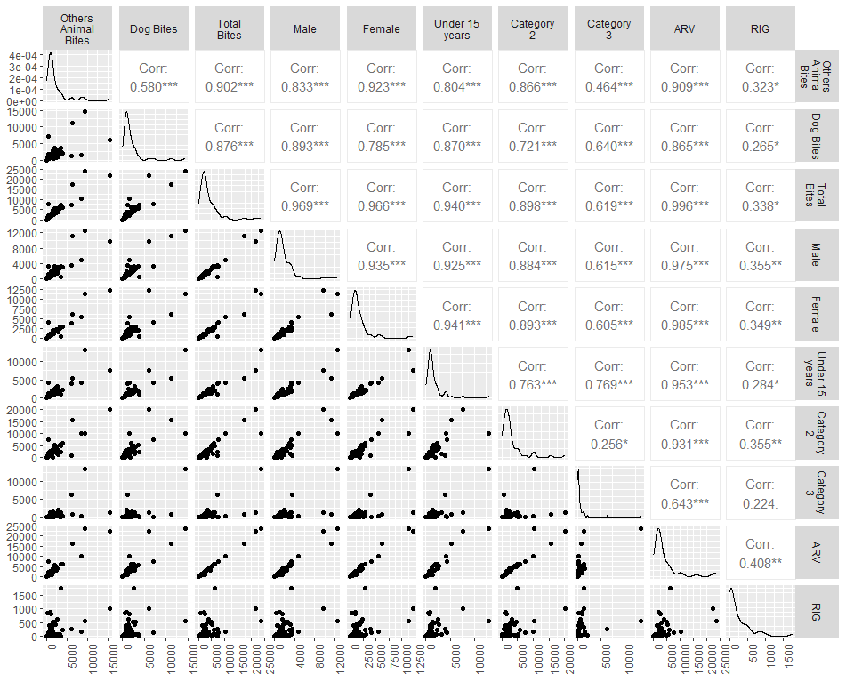

Supplementary Fig. 4: Spearman rank correlation coefficients between various factors for confirmed rabies cases

The Spearman rank correlation coefficients between key rabies patient characteristics and ARV variables point to a statistically significant association between these two variables (Figure 1). Dog bites (r = 0.865, p<0.05), other animal bites (r = 0.909, p<0.05), and total bites (r = 0.996, p<0.05) all show a strong positive correlation with the ARV. ARV is also strongly correlated with both male (r = 0.975, p<0.05) and female patients (r = 0.985, p<0.05) in patients.

Table S1: Association with age category and various factors of rabies patients in Bangladesh.

|  |  |  |  |
| --- | --- | --- | --- |
|  | Age Category | | P-value |
|  | ≤15 | >15 |  |
| Vaccination (n=) |  |  |  |
| Absent | 21 (13.04) | 14 (8.70) | 0.004* |
| Present | 0 (0.00) | 5 (3.11) |  |
| Sex (n=) |  |  |  |
| Female | 30 (18.63) | 10 (6.21) | 0.180 |
| Male | 75 (46.58) | 46 (28.57) |  |
| Residence |  |  |  |
| Rural | 29 (18.01) | 13 (8.07) | 0.881 |
| Urban | 6 (3.73) | 3 (1.86) |  |
|  |  |  |  |

In Bangladesh, 13.04% of rabies patients under the age of 15 who were reported had not received the vaccine prior to being harmed. Only 3.11% of people with rabies older than 15 years old had the vaccine before being harmed. The majority of patients (46.58%) are male and under the age of 15 years old. Additionally, the majority of patients are also men (28.57%) among those older than 15 years. The majority of patients (18.01%) are under the age of 15 and come from rural areas.